STOKESLEY FALLEN 1914- 1918  DETAIL FROM PARISH RECORDS | ACTION | GRAVE
Cpl JOHN BARRETT, when quite young joined the Army as a regular soldier. He went to the front at the beginning of the Great War of 1914-1918, and was still a youth when he fell early in the autumn of 1914. He was the first Stokesley man to die in the Great War.  His grave is unknown.  ‘None of is liveth to himself, and none dieth to himself. | 1st Bn Coldstream Guards 29 Oct 1914 Kruisecke  “enemy attacked in large numbers during night of 29th. Regiment low in numbers and overwhelmed. Survivors in deep trenches unable to use bayonets. 1 officer (QM Boyd) + 60 left 180 casualties K W & M Coldstream Guards history  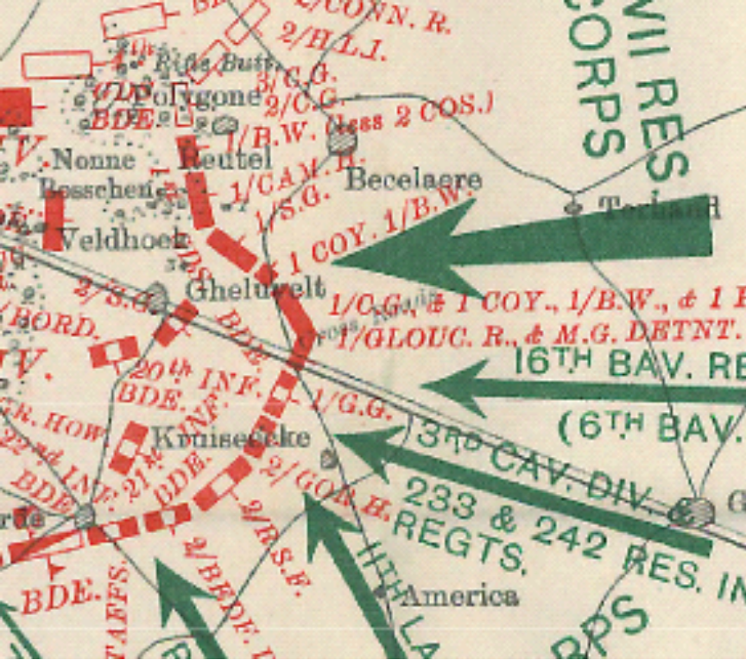 | Menin Gate Panel 11
Private FRED DUNNING FOSTER. No 11535?, of the 2nd DLI, was a regular soldier. He went abroad with his regiment, landing in France on the 8th Sept, 1914. It went into action on the 19th Sept 1914 north of Troyon. He fell on the 27th October 1914, ‘with many more.’ He was 24 years of age; and was one of two brothers serving in the war. His grave is unknown. Son of Mrs. Ann Elizabeth Foster, of White House Cottage, Beck Side, Stokesley, Yorks.’ ‘He that loseth his life shall save it. | 2nd DLI, 27th October 1914 Rue Du Bois  Killed during a period of continuous day and night shelling and sniping, followed by dawn attack 6 am 28th Oct.. Between 21 & 31 Oct Bn lost 2 offr + 15 killed 3 + 40 wounded 7 missing.  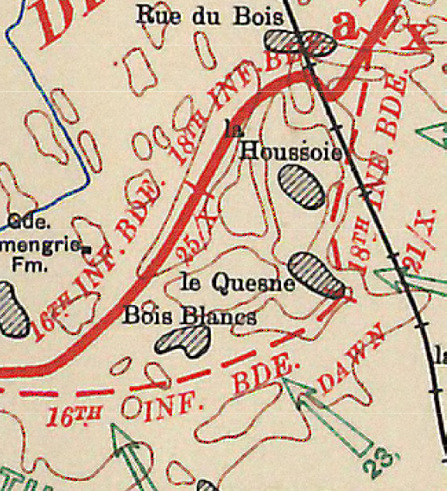 | Ploegsteert Memorial
Company QMS FREDERICK ARTHUR BARR, 4th Battalion. Yorks. He was a native of Newby, and an inn-keeper at Stokesley; also dancing-master, member of the Stokesley Volunteer Band, and for many years vice-captain of the Stokesley Cricket Team. He was one of the four local volunteers who served in the South African War, and possessed the Queen’s Medal with six bars, the Volunteer Long Service Medal for 20 years service, and the 1914-15 Star. The Territorial Regiment volunteered for Active Service upon the outbreak of war; many local men were in its ranks; and on 17th April 1915 they embarked for France and Belgium. The Regiment went into action at St. Jean and St. Julien on the 24th April 1915, and on that day Sergeant Barr was wounded near Ypres. He died at Boulogne General Hospital on the 25th April 1915. His grave is in Boulogne Eastern Cemetary. He was one of three brothers who served in the forces, of whom two fell in action. He was 43 years of age. Native of Seamer, Farm, Yorks. Son of Hannah Appleton, of Newby, Nunthorpe, Yorks. | 1/4thBn Yorkshire Regiment - St Julien  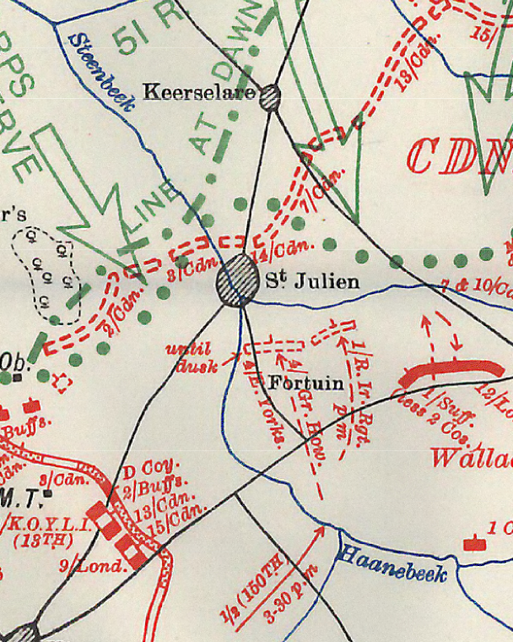 | BOULOGNE EASTERN CEMETERY  VIII. A. 25.  ‘He sleeps with England’s heroes In the watchful care of God.
Cpl John Thomas Caton. 4th Yorks. Solicitors clerk and athlete. On the 25 April 1915, near St Julien, at the defence of Ypres, he fell, where once was a shrine on the Fortuin Road; but his grave is unknown. He was 30 years of age and an only son. He was married, and left three children, of whom one survives.(1930??) Husband of Hannah Eliza Caton, of Garden House, Stokesley, Yorks. | 1/4thBn Yorkshire Regiment St Julien  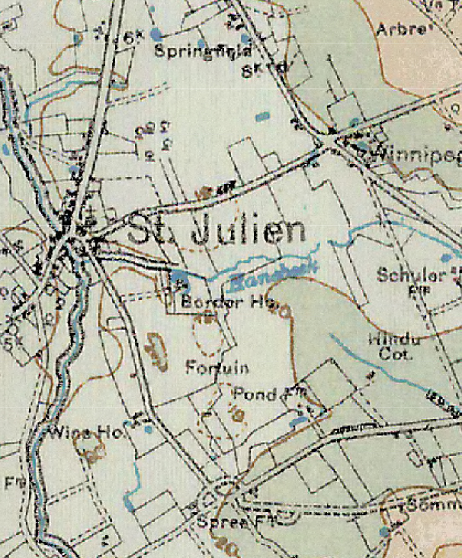 | Menin Gate Panel 33
Pte Thomas Henry HARTAS, No 1946? of the 4th Yks, Territoral Forces. On the 4th May he was wonded, and lying in a ruin to which he had crawled, was found some days afterwards. Died in hospital at Cambridge, on the 19th May, 1915. He was buried with military hons at Stokesley on Whitsunday, the 23rd May 1915. He was 28 and was married and left 3 children. Son of Thomas and Mary Hartas, of Ampleforth, York; husband of A. E. Hartas, of West Terrace, Stokesley | 1/4thBn Yorkshire Regiment  St Julien | East part. STOKESLEY CHURCH BURIAL GROUND
LCpl WILLIAM SHORE, No 6359? 2nd Yks (says 1st Yorks but not in theatre) , was a regular for 17 yrs. As a reservist rejoined the Army on the 4th Aug, 1914. Fell on 15th June 1915, at Givenchy Brickyard, near Vimy. His grave is unknown, but his memoral is at Bethune. One of 7 brothers, of whom 3 fell. Name on memorial book in Richmond Church. He was 33 | 2nd Bn Yorkshire Regiment Givenchy 15th June  The attack was a complete failure, despite the enormous bravery and dash… The 2nd Yorks, lost heavily in the crossing of no man's land:  Story plus maps of this failure here | LE TOURET MEMORIAL Panel 12
Pte Robert Wood of X Company, the Northumberland Fusiliers, formerly miner. In action at Hill 60 – which is about 3 miles SE of Ypres in Spring 1915. He found one Stokesley friend in his regiment, and gave his last message as they prepared for attack on eve of 16th June 1915 – the battle of Hooge, 2 miles E of Ypres. He want into action and was never seen again. Grave unknown. Name on the Register of the Menin Gate, He was 19. Son of Fred and Emma Wood, of Brick Row, Commondale, Grosmont, Yorkshire | 1st Bn RNF  1st attack on Bellewarde 16 June 1915  No info on role at Hill 60 | Menin gate Panel 8 or 12
Pte WALTER FISHWICK of 1st West Yorks, was a regular soldier and one of 2nd draft. One of the Contemptible Little Army, was awarded the Mons Star. Carrying a despatch he was captured. He succeeded in concealing it in his puttee, and later in escaping, without boots and half-clothed. He met Brit troops who momentarily thought him mad. His info of new enemy advance in the village they were approaching, spared them many casualties. He was in the trench on Xmas Day 1914, when the Saxons opposite laid aside arms for the day, and both sides made friends, exchanging gifts. Loos Sept 1915. With three others, while having their tea, all four were killed by one shell. This was o the 11th October 1915. He was 21 and one of two brothers who served in the Army | Note (This story doesn’t quite add up. 1st Yorks not at Loos or in trenches on 25 Dec.) | POTIJZE BURIAL GROUND CEMETERY  W. 15
John Myers ALDERSON. October 1915 Gallipoli. Axmac Cem, Suvla. Private 18212 Princess of Wales's Own (Yorkshire Regiment), 6th (Service) Battalion Son of the late William ALDERSON & Elizabeth Ann ROBINSON, of High Green, Stokesley, Yorkshire Born: 1896 Burby Yorkshire Died: 20-Oct-1915 Killed in Action aged 19 Of the Preston Grammar School, butcher, left England in September 1915, and went to Egypt, thence to the Dardanelles, in October. While restoring wire entanglements at midnight, he was wounded; his friends brought him back to the British lines. He lived only one hour; by his friend Private Farnaby he sent home his last messages; and desired that his Bible be sent to his mother. He died on 20th October 1915. He was 19 years of age. From the Parish Magazine; “He died in the service of his country. He was confirmed of 1910; a soldier of Christ as well as of his King and country "Think not that I am come to destroy; I am come not to destroy, but to fulfil". | Gallipoli | Azmak Cemetery, I. F. 24, Suvla
Pte CLAUDE BELL. 2nd Yorks, Newby farm worker. Fell 25th Feb 1916. He was 30. Carnoy Cemetary, about 5 miles e of Albert.
Cpl Andrew Geo HENDERSON. 2nd Fld Coy RE. Wounded 17 March 1916 and died on 18th March. He was 27. Grave Sailly-sur-la-Lys Canadian Cemy. | Not known | SAILLY-SUR-LA-LYS-CANADIAN CEMETERY I. C. 61
2nd Lt PERCY DARRELL DENMAN, of the Green Howards. Joined Army 1895. Drafted to India. Fell in action on the Somme on 1st July 1916. his grave is in the Peronne Road Cemy, Maricourt, SE of Albert. He was 41, married and left 2 children. Indian Frontier Medal. Mentioned in Despatch from Sir John French dated 30th Novemeber 1915 for ‘gallant and distinguished service in the field. | 2nd Bn Yorkshire Regt  30 Div Capture of Montebaun | PERONNE ROAD CEMETERY, MARICOURT  IV. H. 35.
Pte JOHN RICHMOND served in the 10th, 12th And13th West Yorks Regiment. Formerly of Newby. Wounded Loos. Recovering in England. Farewell words at the Railway Station were ‘I shan’t come back this time, Father.’ Fell at Somme 1st July 1916. He was 20 and an only son, and is buried in a common grave of 50 at Fricourt New Military Cemy Son of Thomas and Mary Richmond, of 10, Redcar Rd., South Bank Yorks. Born at Egton, Yorks | 10th West Yorks Regiment Fricourt 1st day of somme captured with heavy casualties | Fricourt Mil Cemetry
Pte ARTHUR SHORE of the 10th and 14th Yorkshire Regiment, tried several times to enlist, but was refused on account of his youth, and because so many brothers were already in the forces. A year after leaving the Church Choir hs succeeded in enlisting, when only 17. Six months after his enlistment, and after a fortnight in France, he fell in action, on the 1st July, 1916. He was 17, and one of seven brothers who served in the Army, of whom three fell in action. His grave is unknown: his name to be commemorated on one of the Somme Memorials. | 10th Yorkshires21st Div Fricourt Mametz | Thiepval memorial  Pier and Face 3 A and 3 D
Capt ALEC FORBES, the 2nd Royal Warwickshire Regiment, was formerly a bank clerk. He enlisted in the Artists’ Rifles on the 5th August 1914. Received commission in February 1915, and was in the battles of Neuve Chapelle, Festubert, and the Somme. MID and awarded the Mons Star. He was first reported missing, and later killed, at Ginchy, on the 3rd September 1916 His grave is in Delville Wood Cemetery. He was one of two only brothers, both of whom fell in action. He was 28 years of age. Son of William Guthrie Forbes and Louisa Ross Forbes, of Springfield, Stokesley, Yorks | 2 Royal Warwicks | Delville wood Cemetry  XVII. K. 2
Lance-Corporal JOHN MILLER of the 13th Yorks, painter, he went abroad in August 1916. He had been in France only a week and had only been able to send one field post-card home, when he fell in battle on the Somme, on the 8th September 1916. All around him perished; there were no survivors to tell anything; so that his grave is an unknown grave. His name is to be commemorated on a memorial to be erected at Arras. He was 38 years of age; he was married and left five children, motherless since 1921; of whom three survive.(in 1930?) | Bantum Battalion of 40th Div. Holding the line | Arras memorial bay 5
Pte WILLIAM COCKFIELD of 4th Yorks, and of the 150th Battalion Machine Gun Corps, was formerly a gardener, and as a member of the local Territorials was mobilised on the 4th August 1914. He went abroad on the 17th April 1915 and was at the Battle of Ypres. He fell in action at High Wood, near Martinpuish, Somme, on the 15th September 1916; but his grave is unknown. He was 25 years of age, and was one of two brothers who served in the forces. He left a widow. | 150 Bde Co Machine Gun Corps 50th Div Martinpiuch | Thiepval Memorial  Pier and Face 5 C or 12 C
Private JOHN GEORGE SKEEN, 4th Yorks and later of the 10th Yorks, was formerly a poultry dealer. He went abroad in early May 1916. He fell at High Wood, near Martinpuich, Somme on the 15th, September 1916 but his grave is unknown; He was 22 years of age. | 50th Div | Thiepval Memorial  Pier and Face 3 A or 3D
Pte JAMES FREDERICK GLASPER of the KOYLI, was educated at the Preston Grammar School, Stokesley. He was a clerk, and a member of the Stokesley Volunteer Band. Early 1916 in 1916, as soon as he had reached military age he joined the 2nd East Yorks and was in training in Newcastle. While there he was 37th in a foot race of 2000 soldiers. He went to France in July 1916 during the Battle of the Somme, and was there transferred to the KOYLI He was reported missing on the 16th September 1916. There was none near him left alive to tell one word of him, and his grave is unknown. He was 19 years of age, and an only surviving child. | 9th KOYLI 64th Brigade, 21st Division | Thiepval Memorial  Pier 11 C and 12 A.
Corporal HARRY JOHNSON of the 4th Yorks was formerly a bricklayer. He went to France in Novemebr 1915. He was wounded at the battle of the Somme and died on the 21st, September 1916 at Camieres near Etaples. He was 27, and was one of four brothers serving in the forces, of whom two fell. On his tombstone is written: ‘Until the day dawn and the shadows flee away’. Son of William and Annie Johnson, of 166, Borough Rd., Middlesbrough, Yorks, late of Stokesley, Yorks | 4th Bn | XVI. A. 4A. ETAPLES MILITARY CEMETERY
Pte GEO JOHNSON of the 9th Battalion KOYLI, was formerly a carter and joined the army early in the war. He was then quite young, ‘for it was not so very long after he had been confirmed’. His youth kept him in England till he was 19. He went abroad in 1916 and died of wounds at the Battle of the Somme on the 28th September 1916, aged 19. He was one of four brothers who served in the army. His grave is at Heilly Station Cemetary 2 ½ miles NNE of Corbie. On his headstone is written: ‘I leave my loved one in they care Until the day dawns. Son of George Johnson, of Stokesley, Yorks | 9th KOYLI 21 Div | : HEILLY STATION CEMETERY, MERICOURT-L'ABBE  IV. I. 55.
Pte THOMAS FARNABY 4 and 6th Yorks, joined Kitchenener’s Army after completing apprenticeship as a painter, spending Xmas 1914 in Richmond Camp. He went to the Dardanelles, where, ‘with the enemy and the sea all around them, he and his comrade were 12 weeks in the trenches without a rest. There it was hotter at midnight than the hottest day of July at home.’ When Pte Alderson died, Pte Farnaby was with him and sent home his last words. Pte Farnaby went next to the Suez Canal; then to France, where he was in the first battle of the Somme. He fell while ‘resting’ on the 24th September, 1916, at La Boiselle, with four or five others all slain by the same shell, and in the presence of a fellow-townsman, all were buried together in a common grave, at what is thought to be Bousincourt French Cemetary, Hamel. He was 24 years of age. Son of Robert and Sarah Farnaby, of West Green, Stokesley, Yorks | 6th Yorks 32 Bde 11th Northern Div | Thiepval 3 a or D
Pte TOM LEE pf the 7th Yorks, was formerly a groom; he went abroad on the 30th January, 1916. He was wounded in July, and recovered, but fell on the 5th (or is it 6th), Novemeber, 1916, a Sunday. He was 20, and lies in unknown grave. His name is to be commemorated on one of the Somme memorials. | 50 Bde 17th Div | Thiepval 3 a or D
Pt THOMAS EELES TAYLOR, KOLI, was formerly employed by the N.E. Railway Co. He went to France on the 9th June, 1916 and died of wounds on the 7th April 1917. He was 21 and had a brother serving in the forces. His grave is at Aubigny, West of Arras. From his last letter:- ‘All my thoughts are of home and you.’ Son of Mrs. M. J. Taylor, of 56, Lindley St., Holgate Rd., York, and the late T. T. Taylor. Born at Stokesley, Yorks. | 12th KOYLI - not engaged around 7th April.1917 | I. K. 45.  CemeteryAUBIGNY COMMUNAL CEMETERY EXTENSION
Signaller JOHN RONTREE BAINES, 10th Yorks, formerly a cycle repairer, enlised in 1914 when 19, joining the4thYks; he was later transferred to the 10th Yorks and was drafted to France in November 1916. When going into action he fell on the 12th April, 1917. He was buried at Cojeul Brit Cemy, St. Martin-sur-Cojeul, 8 miles north of Bapaume. On his gravestone is the inscription: ‘Thy will be done.’ From his friends at the front:- ‘Your dear son was a great favourite……all feel his loss.’ ‘Always so cheerful; he never flinched from his duty.’ ‘His winning ways won him many friends.’ ‘He seemed so happy.’ ‘He has made a great and noble sacrifice giving all for the sake of his country and those he held so dear. Now he is in a better land enjoying the reward we have still to merit. Let us live in the sure and certain hope of meeting our dear ones again when God call up his own.’ ‘Do not forget he gave his life in the greatest of all causes: he and those like him, they who have served England. His last thoughts would be with you Son of John Rontree Baines and Louisa Baines, of High St. Stokesley, Yorks | 21 Div | COJEUL BRITISH CEMETERY, ST. MARTIN-SUR-COJEUL  D39
Sgt FRED SHORE, MM., No.200334, 4th Yorks Territoral Regt, was formerly a bricklayer. His regiment was in camp in Wales when the war broke out; the batallion returned to Stokesley to await orders and on the 4th. of August it mobilised at Northallerton. He received the MM ‘for conspicuous bravery near Martinpuich, Somme, on the 15th. September 1916. He fell on the 21st. April 1917, near Arras, and was buried in the presence of an elder brother at Hibers Trench British Cemetary, Wancourt, S.E. of Arras. HE was one of seven brothers who served in the army to whom three fell in action. He was 24 | 50th Div | B. 4.  Cemetery: HIBERS TRENCH CEMETERY, WANCOURT
Pte HARRY CARTER, No 1041, 4th Battalion of the 4th Yorks (stet), was formerly a labourer, and went abrad in the spring of 1915. During the 2nd battle for the defence of Ypres, near which town Messers. Barr, Catan and Hartas had fallen; he also fell a victim. On Whitmonday, 24th May 1915, the then new poison-gas was used by the enemy, so that many of our men suffered and died in great agony. Harry Carter was one who had to face it. He was rescued in time to be taken to a Field Hospital, but his speech was taken away for some months. He was brought back to England, first to Cambridge Hospital, then to Aysgarth Sanatorium, and then to his own home, where after much and long suffering, he died on the 11th. May 1917. He was 25 years of age. At his military funeral at Stokesley on the 15th May 1917 the Stokesley band played ‘The Dead March in Saul,’ ‘Days and Moments quickly passing,’ and the Last Post was sounded. ‘Until the day dawn and the shadows flee away. : Son of John and Jane Carter, of West Green, Stokesley | Gas attack St Julien | SW part of STOKESLEY CHURCH BURIAL GROUND
Pte JOHN CROPPER, 9 Yorks and Lancs 09/06/1917 | 23 Div Messines Ridge | Menin gate 36 &55
H W CARTER  Private 8th Bn The Queen's (Royal West Surrey Regiment) 14/06/1917 | 32 Div | XIV. F. 7A. LIJSSENTHOEK MILITARY CEMETERY
Private W J JOHNSON  2nd Bn Royal Inniskilling Fusiliers  . Age: 27  Date of Death: 10/08/1917  Service No: 41495  Additional information: Son of Mr. F. and Mrs. M. A. Johnson, of Lee Terrace, Stokesley, Yorks.  Casualty Type: Commonwealth War Dead | Neuiport operation | Grave/Memorial Reference: I. B. 22.  Cemetery: RAMSCAPPELLE ROAD MILITARY CEMETERY
PRIVATE ERNEST BARKER 30/10/1917 KIA TYNE COT AREA | 1st/28th Bn Artist Rifles 63RD Div | Panel 153 Tyne Cot Memorial
STEPHEN ERNEST HAROLD RICHARDSON,  Private 1st Bn.: Northamptonshire Regiment  Age: 19 Date of Death: 10/11/1917  Service No: 40766 Son of Isaac, George and Anne Dorothy Richardson, of West End, Stokesley, Yorks.: | 2nd Passendaele 1st Div | Panel 104 to 105.  Cemetery: TYNE COT MEMORIAL
Private J W MUDD  1st/5th Bn. Yorkshire Regiment  Age: 22 Date of Death: 27/12/1917  Service No: 201822  Additional information: Son of Michael and Amie Mudd, of West End, Stokesley, Yorks. | Passendaele | II. F. 5.  Cemetery: TYNE COT CEMETERY
ALLAN RICHMOND,  Air Mechanic 1st Class 1st Training Depot Station Royal Air Force Age: 31 Date of Death: 01/04/1918 Service No: 94557 Additional information: Son of John and Elizabeth Richmond; husband of Mary Amelia Richmond, of West Terrace, | Training accident | South-East part. Cemetery: STOKESLEY CHURCH BURIAL GROUND
Private HENRY BARKER, 4th Bn. East Yorkshire Regiment Age: 24  Date of Death: 10/04/1918  Service No: 205679  Additional information: Son of Emily Barker, of East End, High Green, Stokesley, Yorkshire, and the late Henry Barker. | 50 Div – Battle of the Lys | B. 6.  Cemetery: HAVERSKERQUE BRITISH CEMETERY
Lt ALEC BETHUNE PETER WOODD  3rd Bn att 10th Bn West Yorkshire Regiment  25/08/1918  Son of Lieut. Comdr. Arthur B. Woodd (R.N.V.R.) and Alice A. Woodd, of Hampstead, London. Educated at Heddon Court, Repton and Hertford College, Oxford. Ordained in York Minster, Oct., 1914 Curate of Stokesley Church | 17th Div V Corps Second Battle of Albert 1918 | FIENVILLERS BRITISH CEMETERY  B. 3.
Private J W PAYLOR  55th Bn.: Machine Gun Corps  Age: 22  Date of Death: 06/09/1918  Service No: 148607  Additional information: Son of Thomas and Elizabeth Paylor, of Stokesley, Yorks. |  | VI. A. 25.  PERNES BRITISH CEMETERY
Maj WG Forbes M.C. RGA 26/09/1918  Son of Louisa Ross Forbes, of Springfield, Stokesley, Yorks., and the late Dr. William Guthrie Forbes | 135th Heavy Bty.RGA | C. 13.  Cemetery: THILLOY ROAD CEMETERY, BEAULENCOURT
Gunner H F MUDD  Nationality: United Kingdom  Regiment: Royal Field Artillery  Unit Text: 81st Bty. 5th Bde.  Date of Death: 18/10/1918  Service No: 246455 | Cambrai 1918 | V. A. 33.  Cemetery: PREMONT BRITISH CEMETERY
A/Bdr, HARRY ERNEST ALLISON, 21/10/18 | 43rd Anti-Aircraft Coy | Stokesley
WGTG Richardson Arras no records
Two possible CWGC records – see below
A Webster age unknown Cassel POW  22/10/1918 Son of the late Elizabeth Webster | 1st East Yorks 21 Div  Prisoner Kaiserschlacht | VI. G. 15.  NIEDERZWEHREN CEMETERY

Two Richardsons – not sure which is our man. CWGC records

Name: | RICHARDSON, GEORGE
Initials: | G
Nationality: | United Kingdom
Rank: | Private
Regiment: | King's Own Yorkshire Light Infantry
Unit Text: | 9th Bn.
Age: | 19
Date of Death: | 27/05/1918
Service No: | 34662
Additional information: | Son of Sarah Jane Mulholland (formerly Richardson), of 36, Arthur St., Middlesbrough, Yorks, and the late George Richardson.
Casualty Type: | Commonwealth War Dead
Cemetery: | SOISSONS MEMORIAL

 | RICHARDSON, GEORGE
Initials: | G
Nationality: | United Kingdom
Rank: | Private
Regiment: | Yorkshire Regiment
Unit Text: | 4th Bn.
Date of Death: | 13/11/1918
Service No: | 242490
Casualty Type: | Commonwealth War Dead
Grave/Memorial Reference: | Panel 5.
Cemetery: | VIS-EN-ARTOIS MEMORIAL

